WI-UI/UX
Assignment 1
Task 1: Creating Git Repository
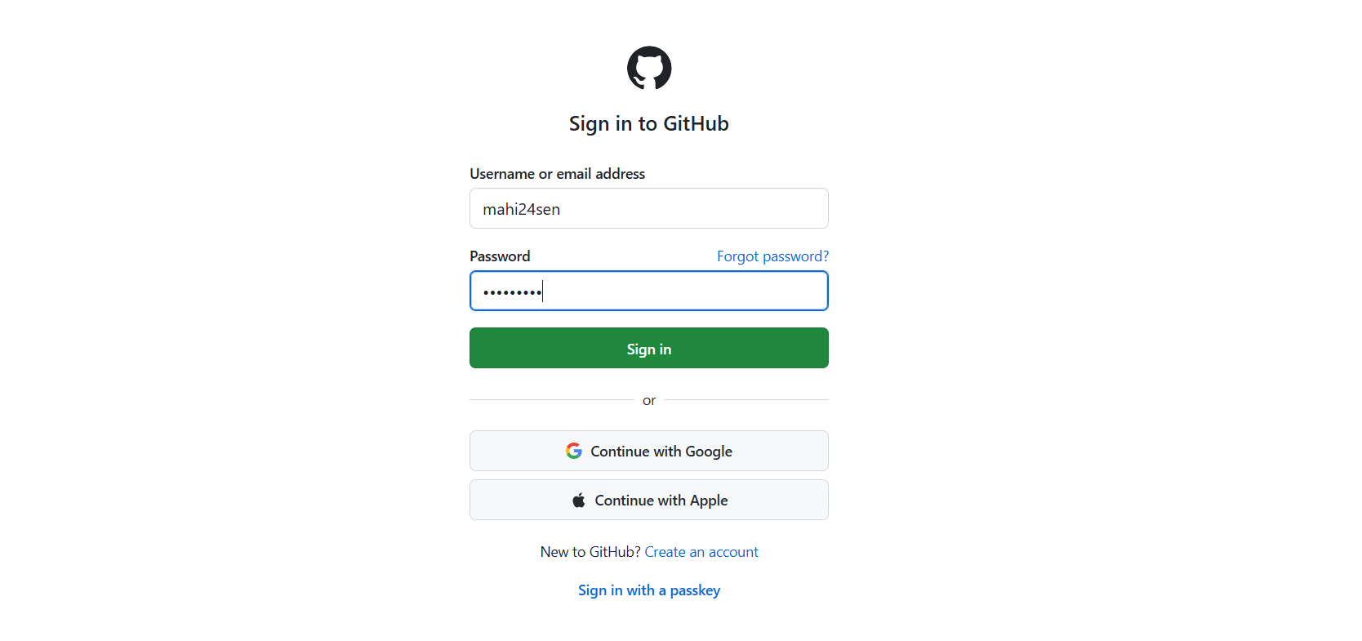
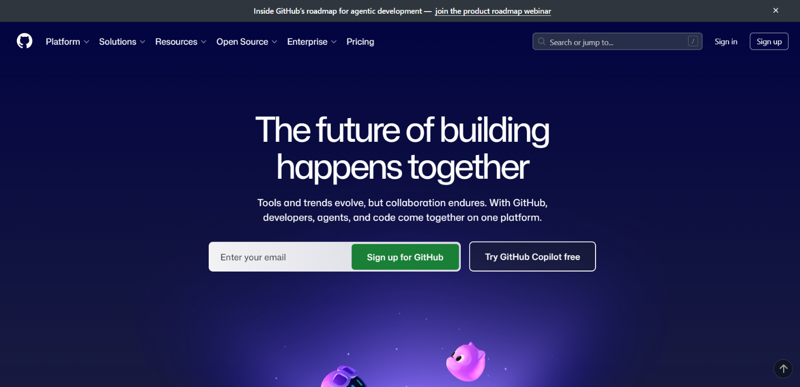
Step 1: Opened GitHub website and logged into my account.

Step 2: Clicked on the "+" icon and selected "New Repository".
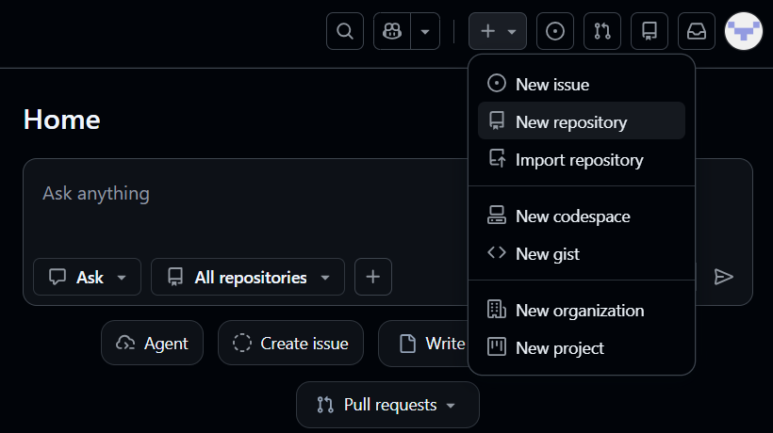

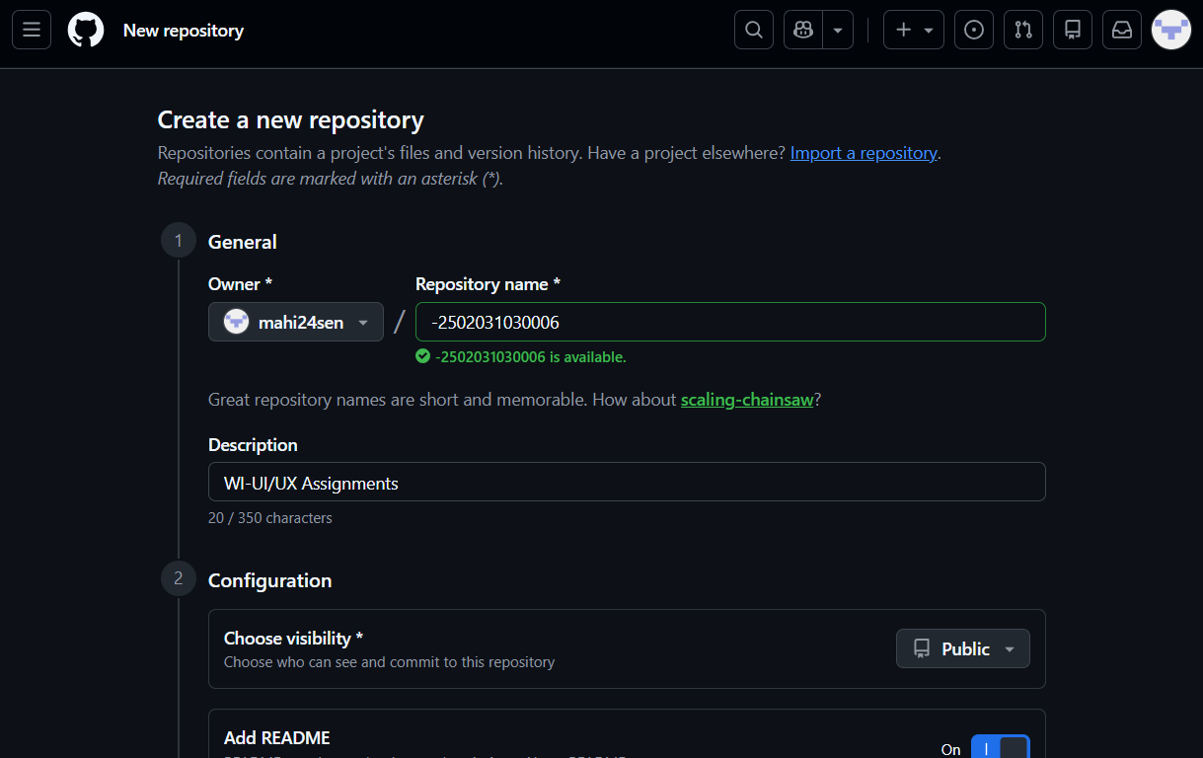
Step 3: Created a repository with my Enrollment number as the repository name and selected public visibility and added a README file.

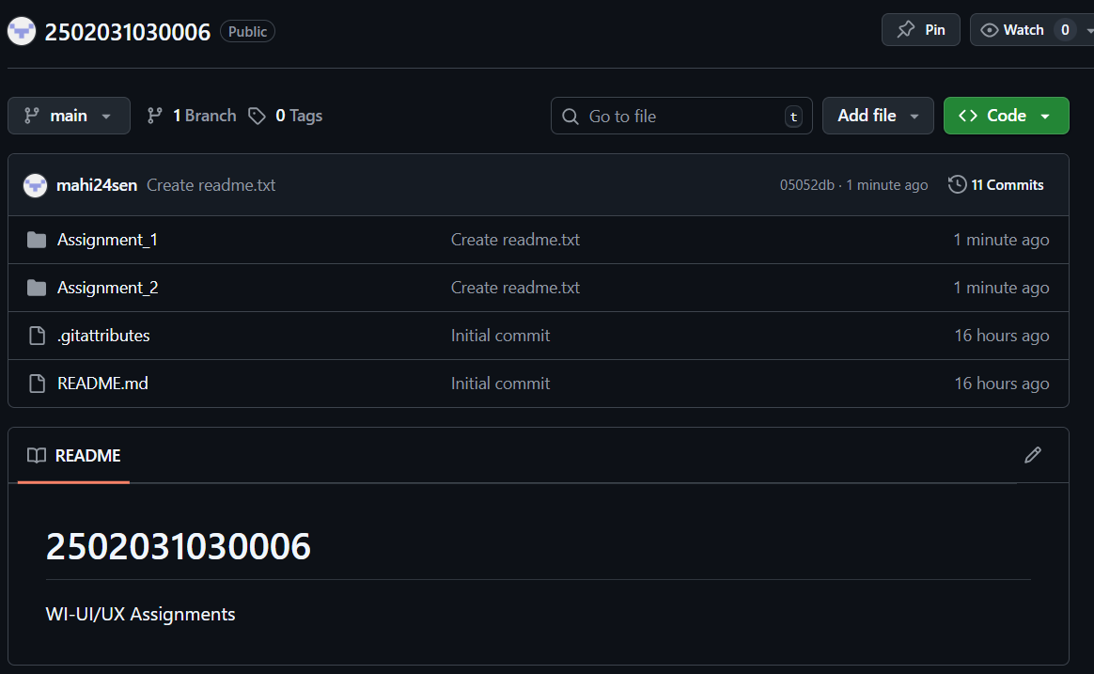
Step 4: Created two folders named Assignment_1 and Assignment_2.

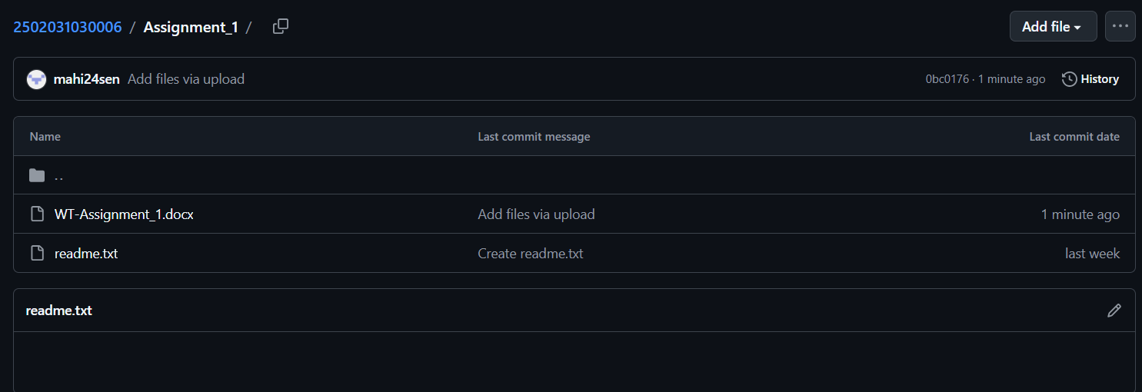
Step 5: Uploaded assignment files in the respective folders.

Step 6: Copied the repository link and submitted it in Google Form.
